MSSQL Interview Questions

What is MSSQL and how does it differ from other SQL databases?
SQL (Structured Query Language) is a standardized programming language used for managing and manipulating relational databases. It is particularly known for its ability to handle structured data, which involves tables and the relationships between them.
MSSQL, also known as Microsoft SQL Server, is a relational database management system (RDBMS) developed by Microsoft. It is used to store and manage data, providing the ability to query, update, and manage databases.

What are primary keys and foreign keys in MSSQL? How do they function in a database?
In Microsoft SQL Server (MSSQL), primary keys and foreign keys are fundamental components of the database schema that help enforce data integrity and establish relationships between tables. Here's a detailed explanation of each:
Primary Keys
A primary key is a column or a set of columns in a table that uniquely identifies each row in that table. It has the following characteristics:
- Uniqueness: Each value in the primary key column(s) must be unique. This ensures that no two rows have the same primary key value.
- Not Null: Primary key columns cannot contain NULL values.
- Single or Composite: A primary key can be a single column (single-column primary key) or a combination of columns (composite primary key).
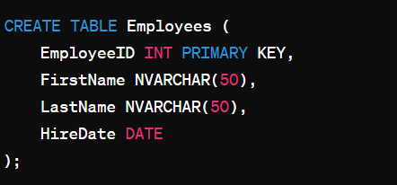
In this example, EmployeeID is the primary key of the Employees table, ensuring each employee has a unique identifier.

Foreign Keys
A foreign key is a column or a set of columns in a table that provides a link between data in two tables. It references the primary key column(s) of another table (or the same table) to enforce referential integrity.
Function: Foreign keys are used to maintain relationships between tables and ensure that the data in one table corresponds to valid data in another table. They prevent actions that would destroy these relationships, like deleting a record that is referenced by a foreign key.
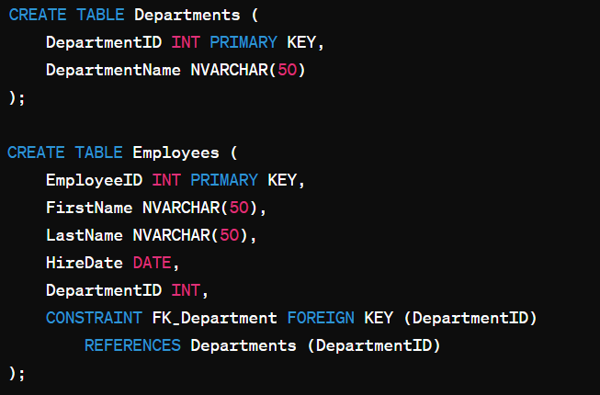

In this example:
- DepartmentID is the primary key of the Departments table.
- DepartmentID in the Employees table is a foreign key that references the DepartmentID in the Departments table.

Cascading Actions: Can define actions like ON DELETE CASCADE or ON UPDATE CASCADE, which automatically delete or update related rows in child tables when a row in the parent table is deleted or updated.

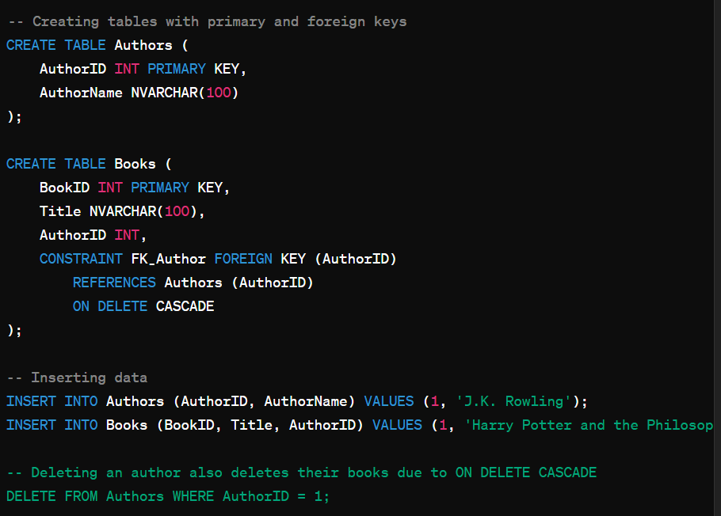

In this example, deleting an author with AuthorID = 1 will also delete all books written by that author due to the ON DELETE CASCADE action defined in the foreign key constraint.

Explain the different types of joins in SQL Server.
In MSSQL Server, joins are used to combine records from two or more tables based on a related column between them. There are several types of joins in MSSQL Server, each serving a different purpose:
- Inner Join
Returns only the rows that have matching values in both tables.
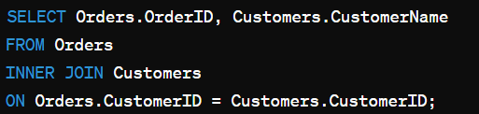
This query returns only the orders where there is a corresponding customer.

- Left Join (or Left Outer Join)
Returns all the rows from the left table and the matched rows from the right table. If no match is found, NULL values are returned for columns from the right table.
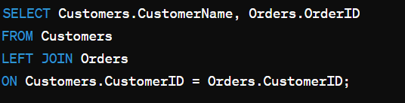

This query returns all customers, with their orders if they have any. If a customer does not have an order, the OrderID will be NULL.

- Right Join (or Right Outer Join)
Returns all the rows from the right table and the matched rows from the left table. If no match is found, NULL values are returned for columns from the left table.
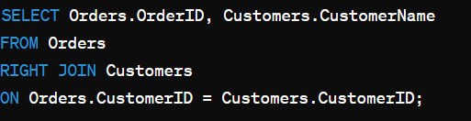

This query returns all orders, with their customers if they have any. If an order does not have a corresponding customer, the CustomerName will be NULL.

- Full Join (or Full Outer Join)
Returns all the rows when there is a match in either the left table or the right table. If there is no match, the result is NULL on the side where there is no match.
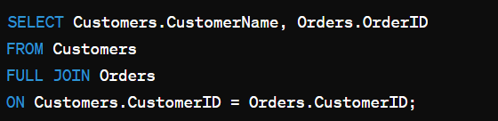

This query returns all customers and all orders. For customers without orders, OrderID will be NULL, and for orders without customers, CustomerName will be NULL.
- Cross Join
Returns the Cartesian product of the two tables. This means that it returns all possible combinations of rows from both tables.
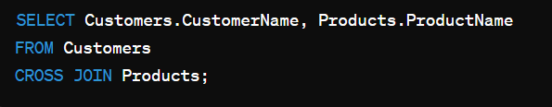

This query returns every combination of a customer and a product.

- Self Join
A self join is a regular join but the table is joined with itself.
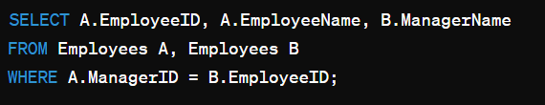

This query returns employees along with their manager’s name by joining the Employees table with itself.

- Natural Join (Not a specific keyword in MSSQL, usually done using INNER JOIN)
A type of INNER JOIN that automatically joins tables based on columns with the same name and compatible data types. Note: MSSQL Server does not have a specific keyword for natural joins. You usually perform this by using INNER JOIN with USING.

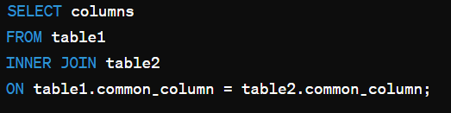

This behaves like a natural join if the column names and types are the same.

Describe the different data types available in MSSQL.

Numeric Data Types:
- int (4 bytes, range: -2,147,483,648 to 2,147,483,647)
- bigint (8 bytes, range: -9,223,372,036,854,775,808 to 9,223,372,036,854,775,807)
- smallint (2 bytes, range: -32,768 to 32,767)
- tinyint (1 byte, range: 0 to 255)

Character Strings Data Types
- char(n): Fixed-length non-Unicode string (1 byte per character).
- varchar(n | max): Variable-length non-Unicode string (1 byte per character).
- text: Variable-length non-Unicode data (deprecated, use varchar(max)).

Date and Time Data Types
- date: Stores only date (3 bytes).
- time(p): Stores only time of day (3-5 bytes).
- datetime: Stores date and time (8 bytes, range: January 1, 1753, to December 31, 9999).

Frequently used MSSQL orders
Data querying:
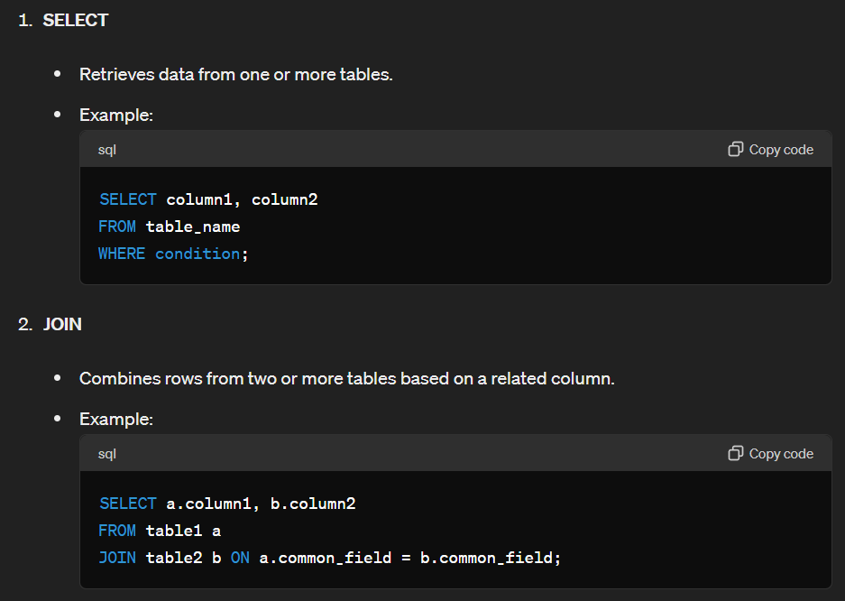

Data Manipulation
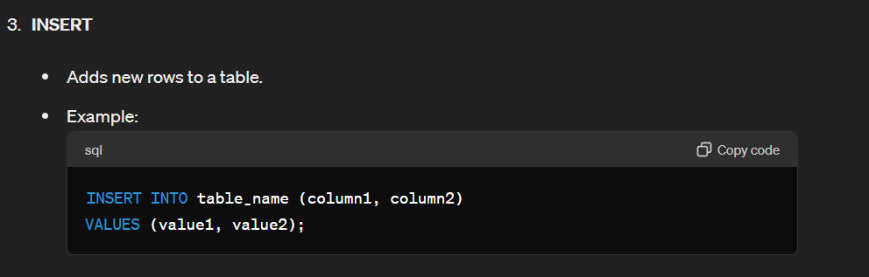
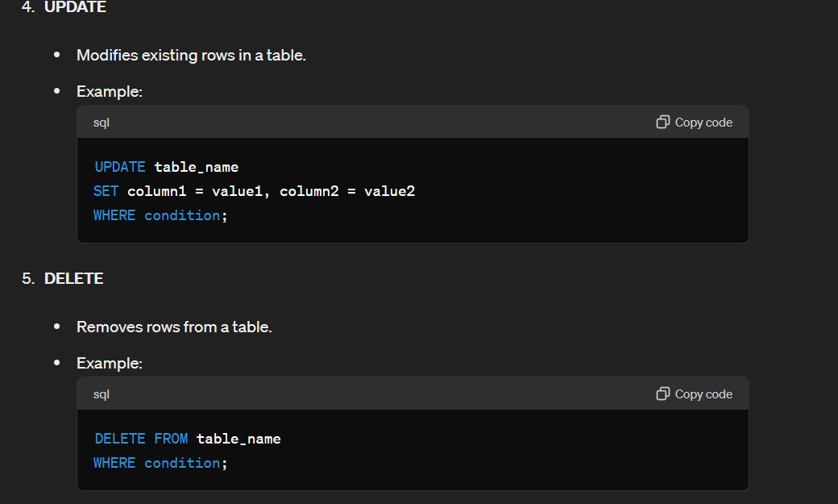
Data Definition
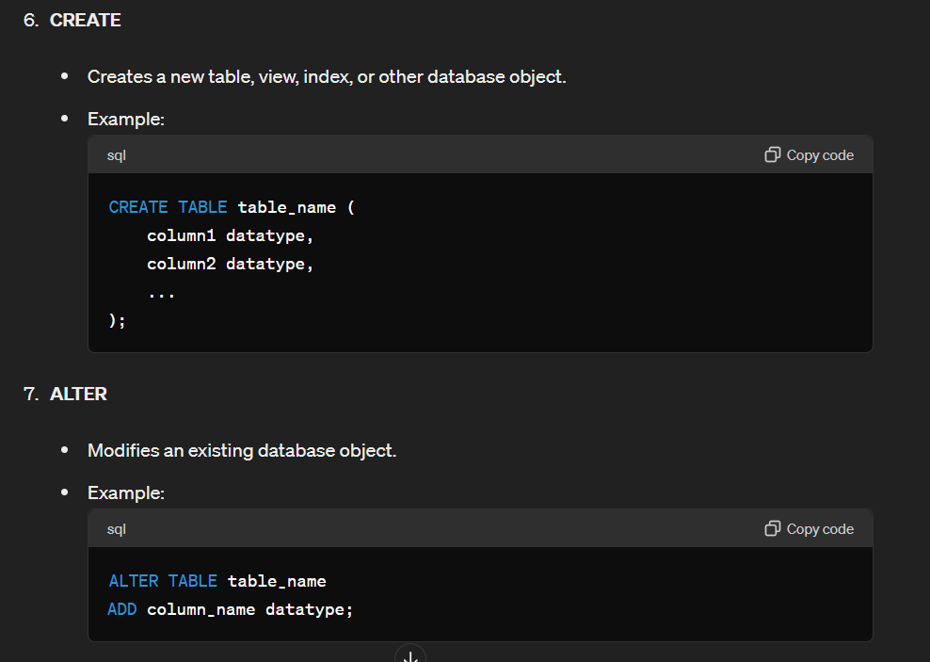
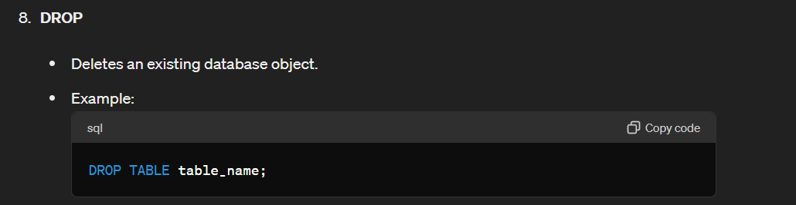
Data Control
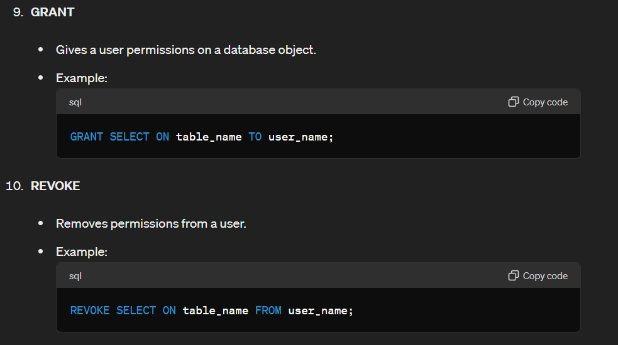

Transaction Control
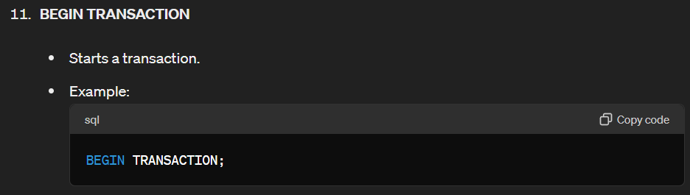
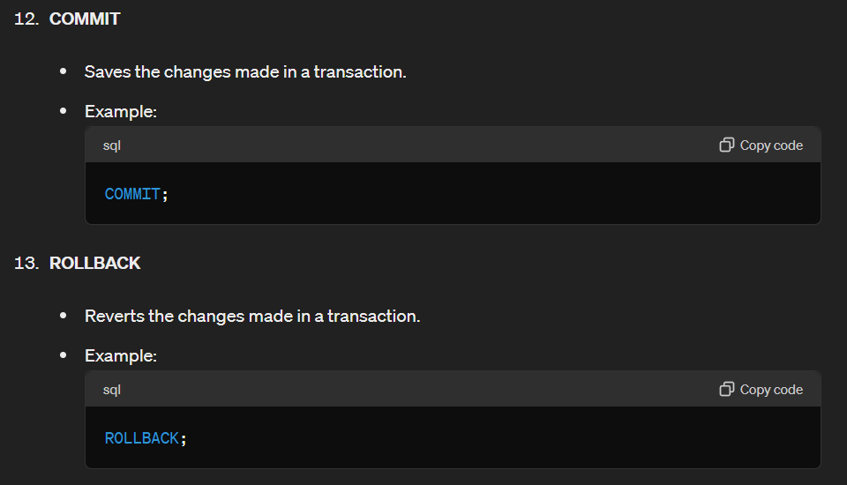

Utility Commands
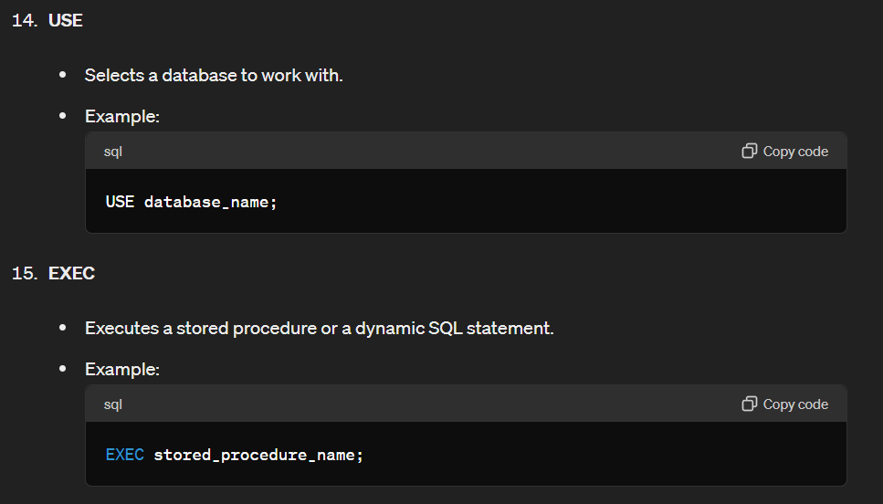

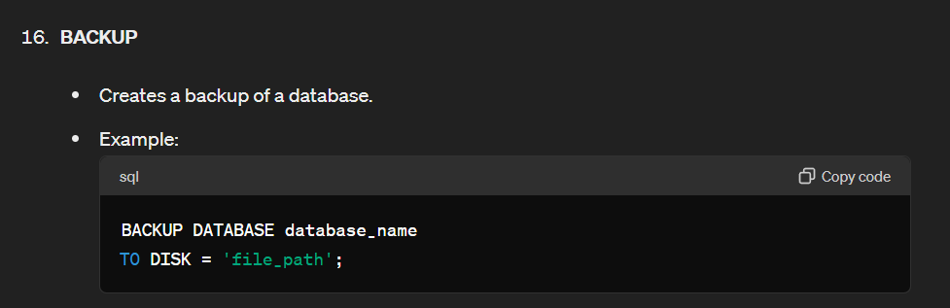

These commands form the core of SQL operations in MSSQL, allowing for effective database management and data manipulation.

What are constraints in MSSQL? Name a few types of constraints.
Constraints in Microsoft SQL Server (MSSQL) are rules enforced on data columns to ensure the accuracy and integrity of the data in the database. They are used to specify rules for data in a table. Here are a few types of constraints in MSSQL:
- PRIMARY KEY Constraint: Ensures that each row in a table has a unique identifier. It does not allow NULL values and must contain unique values.
- FOREIGN KEY Constraint: Ensures referential integrity by enforcing a link between the data in two tables. It creates a relationship between columns in different tables, where the values in the foreign key column must match values in the primary key column of the referenced table.
- UNIQUE Constraint: Ensures that all values in a column or a set of columns are unique across the rows of the table. Unlike primary keys, a table can have multiple UNIQUE constraints.
- CHECK Constraint: Ensures that the values in a column meet a specific condition. For example, a CHECK constraint can be used to ensure that values in a numeric column are within a certain range.
- DEFAULT Constraint: Provides a default value for a column when no value is specified during an insert operation.
- NOT NULL Constraint: Ensures that a column cannot have a NULL value. Every row must contain a valid value for this column.
These constraints help enforce business rules, data integrity, and relationships between tables, making the database more robust and reliable.

What is the difference between CHAR and VARCHAR data types?
The CHAR and VARCHAR data types are both used to store character strings in a database, but they have some key differences:
CHAR is a fixed-length data type. When you define a CHAR column, you specify its length, and it always takes up that amount of space, regardless of the actual length of the string stored in it. For example, if you define a CHAR(10) column and store the string 'cat', it will still take up 10 characters, with the remaining 7 characters padded with spaces. Since CHAR is fixed-length, it can be more storage-efficient for columns where all data entries are of the same length. CHAR can offer better performance for certain operations due to its fixed length, which makes it easier for the database to handle indexing and storage. CHAR is typically used when you know that the data entries will be of a consistent length, such as codes or fixed-length identifiers.
VARCHAR is a variable-length data type. When you define a VARCHAR column, you specify the maximum length of the string, but it only uses as much space as needed to store the actual data, plus an additional byte or two to store the length of the string. VARCHAR is generally more storage-efficient for columns where the length of the data entries varies, as it does not allocate unused space. While VARCHAR can be less performant in some scenarios compared to CHAR, it is often negligible, and the flexibility in storage makes it a preferred choice for variable-length data. VARCHAR is typically used when the length of the data entries can vary widely, such as names, descriptions, or other text fields.

What is the purpose of the WHERE clause in MSSQL?
The WHERE clause in MSSQL (Microsoft SQL Server) is used to filter records in a query, so that only those records that meet specified conditions are returned. This clause is typically employed in SELECT, UPDATE, DELETE, and INSERT statements. Here are the primary purposes of the WHERE clause:
